**Process Document**

**Mautic Implementation**

**Prepared by Juan Carlos Lugo De Gouveia**

**13th February 2023**

**London**

**Gravitai.com**

**Prepared for European Sperm Bank**

**The Objective**

Implementation of Mautic as a marketing automation platform, improving and reinforcing the marketing strategy in different scenarios.

**System requirements**

* Virtual Machine / Sever.
* Ubuntu 18.04 server.
* Ubuntu 18.04 LTS Disk  - 80 GB Storage.
* Apache2 as a web server.
* 2 CPU Cores.
* 4 GB RAM.
* DB – MariaDB (It would be installed in the same instance).

**How it works**

Mautic connect with contacts over channels like Emails, Text Messages, Social media, and Focus Items.

* Contacts segmentation based on business requirements and personalized marketing strategies for each segment.
* Create personalized Campaigns to engage with contacts.
* Use of performance metrics in dashboards, reports, points and stages to measure the efficiency of the marketing strategy.

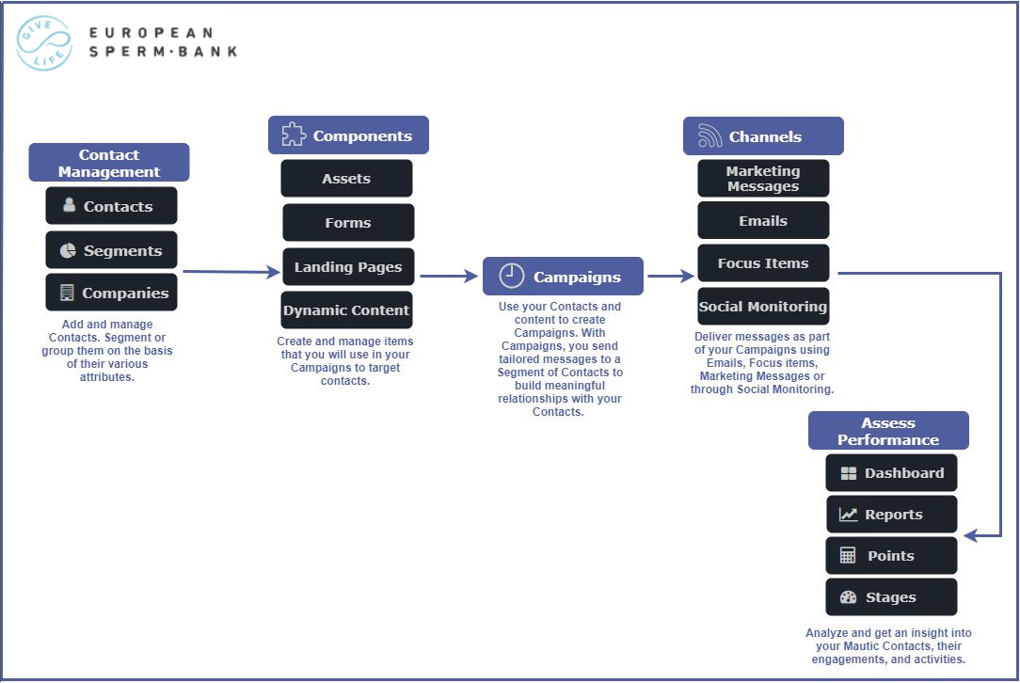

**Users and roles**

Access to Mautic instances is controlled by creating accounts for users, and associating them with a role.

[**Users**](https://docs.mautic.org/en/users-and-roles/managing-users) are the accounts which an individual uses to access Mautic, whereas [**Roles**](https://docs.mautic.org/en/users-and-roles/managing-roles) allow or deny access to various features within Mautic.

**Users**

Users can be managed by an Administrator with appropriate permissions in Mautic by accessing the settings cog wheel at the top right of the screen, and selecting Users.

Create the user by completing all the mandatory fields, adding a signature if required, and assigning them a username and password. Always use a secure password for users with access to your Mautic instance.

It is also possible to set the default timezone and language for the new user, and to set the user to published (able to log in) or unpublished (unable to log in).

You will then need to provide the login credentials to the user to allow them to log in.

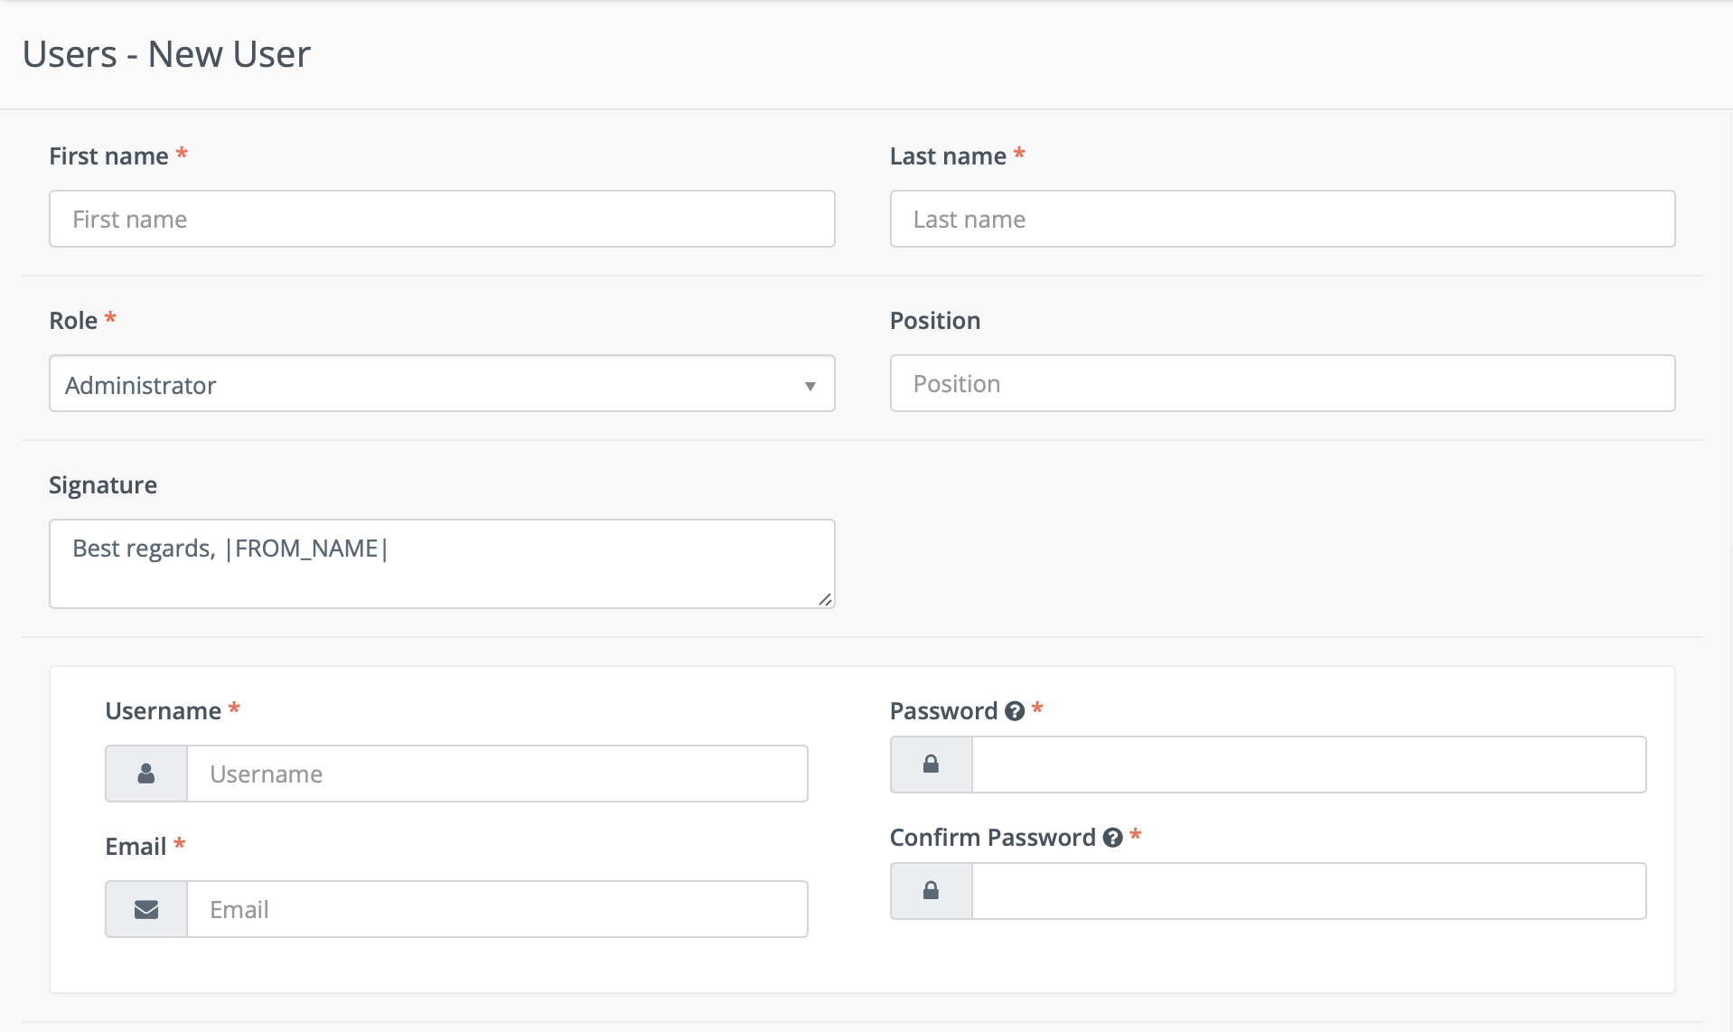

**Roles**

Roles are used in Mautic to control what resources and actions a user can access.

**Creating a new role**

To create a new role, navigate to Roles using an Administrator account via the Settings cog at the top right of the screen and selecting 'Roles'. Then click on 'New'.

**Full System Access**

If you enable the 'Full System Access' switch, you are creating an Administrator account which has the highest level of access to your Mautic instance.

These accounts should be limited, and you should ensure that they have secure credentials.

If you select this option, you will not be able to configure anything under 'Permissions' because by default, this account has full access to everything.

### **Setting granular permissions**

Mautic allows you to create roles with granular permissions for each bundle - or part - of Mautic.

To configure a role, leave the Full System Access switch at 'No' and click on the Permissions tab to start building the role.

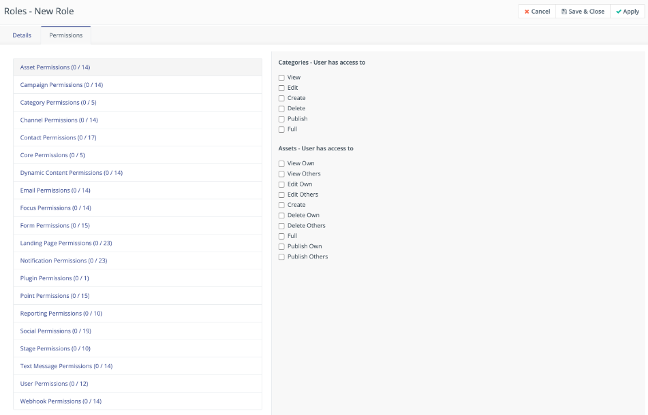

**Explaining the permission options**

There are several different permission options that can be selected:

* View - this allows the users with this role to view this part of Mautic.
* Edit - this allows the users with this role to make changes to this part of Mautic.
* Create - this allows the users with this role to create new resources in this part of Mautic.
* Delete - this allows the users with this role to delete resources in this part of Mautic.
* Publish - this allows the users with this role to make resources in this part of Mautic available by publishing them.
* Full - this allows the users with this role all of the permissions above.

There are permission levels relating to resources the user has created themselves, and those created by others:

* Own - this allows the users with this role to view/edit/delete/publish their own resources in this part of Mautic, but not those created by others
* Others - this allows the users with this role to view/edit/delete/publish their own resources in this part of Mautic, and those created by others

There are permission levels relating to being able to manage resources:

* Manage - this allows the users with this role to manage resources in this area of Mautic (for example, managing custom fields or plugins)

There are permission levels relating to what fields in the Users section can be edited:

* Specified fields - allow or deny the users with this role to edit specified fields in the Users section (e.g. Name, Username, Email, Position)
* All - this allows the users with this role to edit all fields relating to the Users section

**Contacts**

All the individuals who have visited your websites or interacted with you in some way.

**Contact Types**

There are two types of contacts:

* **Visitors** (formerly anonymous leads) — visitors to your site who have not yet been identified by a form or other interaction.
  + These contacts are tracked by Mautic but typically remain hidden so as not to clutter your segment.
* **Standard contacts** — contacts which have identified themselves via a form or some other source. As a result, these contacts typically have a name, email, and other identifying fields.

**Visitors (formerly anonymous leads)**

Visitors are worth tracking, because these could be future customers. By tracking them before they have any interaction, you can retain a log of when they visited your site, which allows you to get a picture of their activity prior to engaging with you.

### **Standard Contacts**

These contacts have identified themselves via a form or other source. You may also have more information about them from previous interactions, or from a third-party system such as a Customer Relationship Management (CRM) tool. As a result, these contacts typically have a name, email, and other identifying information which can be associated with the contact.

The standard contact is the preferred contact within Mautic. These are contacts which may have started as a visitor, but at some point provided additional information such as a name, email address, social network handle, or other identifying characteristics which have enabled you to connect up the activity on your website with a known person. You can nurture these contacts through the Mautic marketing automation platform, learn more about their behaviour, and take specific actions as a result of this information.

### **Companies**

Companies are a way to group contacts based on the company(ies) the contact is assigned to.

**Segments**

Segments provide ways to easily organize your contacts. These segments can be configured from a variety of fields.

When viewing all segments you will notice the column on the right which shows the number of contacts matching that particular segment.

Creating a segment

To create a new segment navigate to Segments in the menu, and click on 'New'.

Naming segments

This is used if the segment is displayed in the Preference Centre, allowing the contact to choose to remove themselves from it. The Public Name is what will be displayed to the contact in the preference centre.

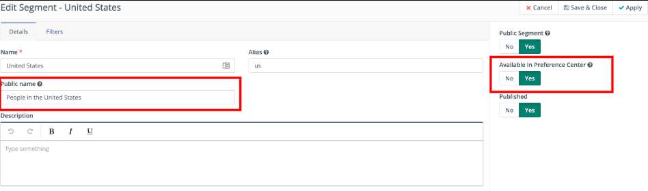

Public and private segments

It is possible to create a segment which is accessible to everybody who uses your Mautic instance - a public segment - or just for your own use - a private segment.

Making segments available in the preference centre

There are many approaches that can be taken when it comes to allowing contacts to choose communications they wish to receive from you. If you wish to allow them to subscribe and unsubscribe based on segments, you can select the option to make a segment available in the Preference Centre.

Use this in conjunction with the public name to provide a user-friendly description of the segment.

Publish status

If a segment is unpublished, it will not be available for use in Mautic, and will not show in any dropdown fields.

Segment Filters

Filters are used to define the contacts who will be in the segment. In addition, these filters can be combined to either be inclusive or exclusive depending on your needs.

Once you have selected the field you can then choose the type of operation to perform. These vary depending on the way you wish to filter your contacts.

If you want to divide your segment based on certain criterion, and you wish to avoid sending duplicate emails to the (sub) segments, you can view and alter them through typing the alias name of the contact segments separated by '+' only. You can add n contact segments to show the contacts they have in common, but you will always receive the result as the intersection of the subsets. You can then manipulate the contacts to remove them from either one subset or all, hence avoiding sending duplicate emails to the same leads in the subsets.

**Components**

The **Components** menu contains the following items:

* Assets
* Dynamic Web Content
* Forms
* Landing Pages

### **Assets**

Assets are those items which you will provide to your contacts typically upon completion of a form. These assets are trackable items and can carry their own point values, history, and tracking statistics.Example Assets

A few common examples of assets include:

* Awhite paper provided in regards a particular product or service
* A downloadable demo application or other digital product;
* Any file of interest to the contact such as video, mp3, presentation, etc.

### **Dynamic Web Content**

The ability to embed content on a web page dynamically for both anonymous visitors and known contacts.

### **Forms**

A form is used to collect user information often in exchange for providing access to a download, an event registration, or an email newsletter. Forms allow you to collect contact data and add additional information to their profile.

There are two kinds of forms in Mautic.

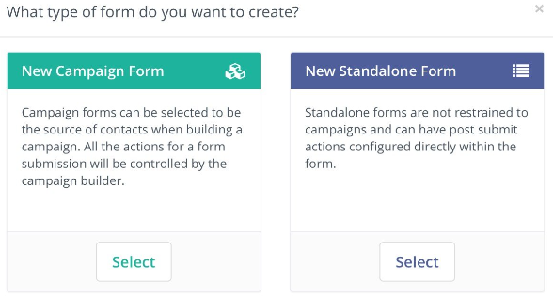

A**Campaign Form** can push a contact directly into a campaign but all actions are performed in the Campaign Builder.

A **Standalone Form** can push a contact into a segment, but not into a campaign directly. The advantage to this form type is that you can perform actions at the time of submission. An example of this would be sending an email to an administrator with the form values included.

**Forms creation**

* Navigate to components - forms. New form.
* Select campaign form to use the form in a campaign.
* Give the form a name.
* Start adding fields into the forms, you can change the label, change whether you want the label to show, give class names and change the validation for each field.

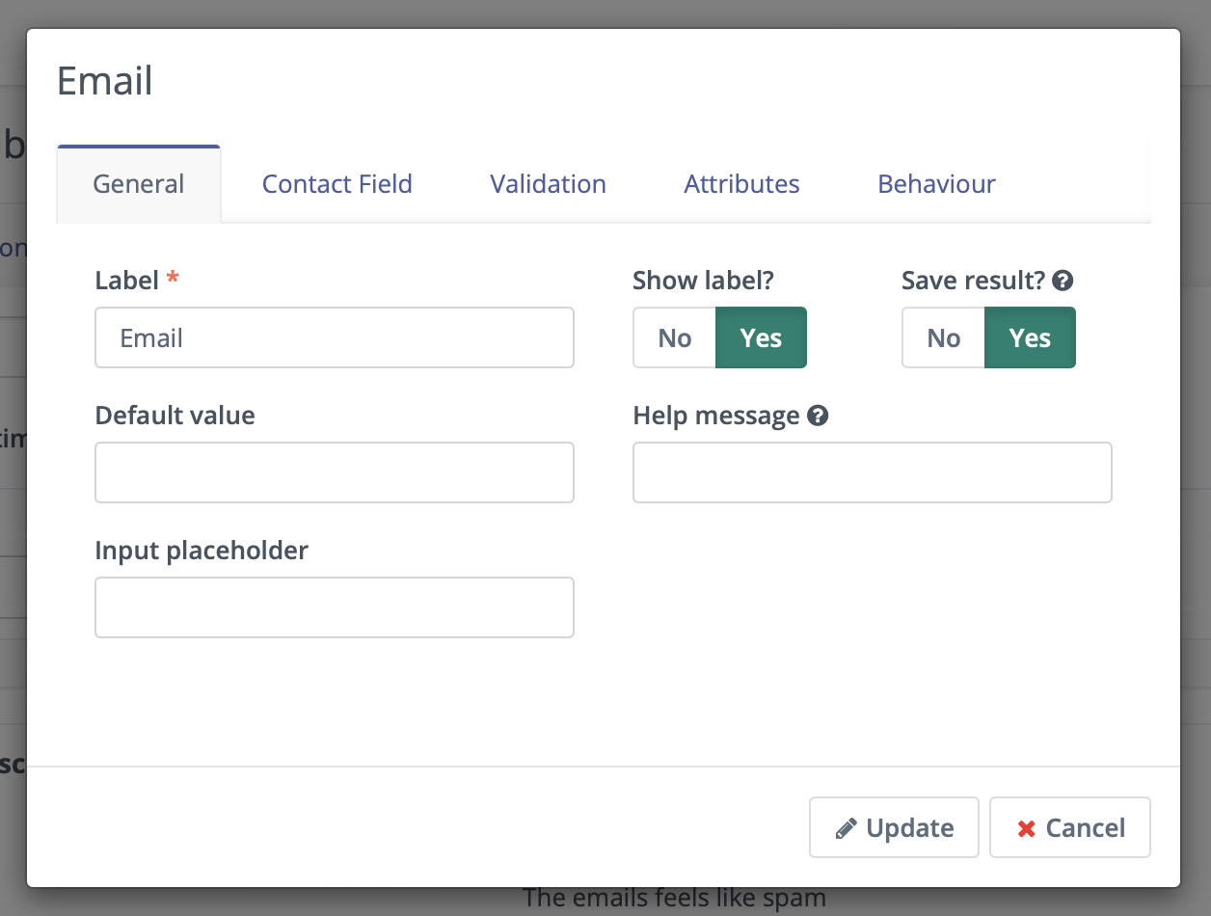

* You can select an action once the user has completed the form. For example if a user subscribes to your newsletter you can choose “send email to user” to send a confirmation email.

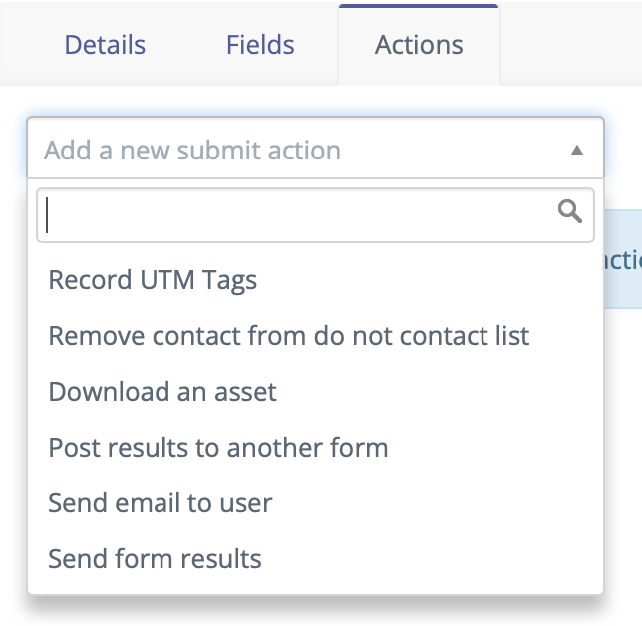

### **Landing pages**

A powerful tool for quickly creating compelling content with a single focus. Use pages for directing contacts through a form or providing a way to download an asset, or merely tracking interest in a particular subject.

We've built an unsubscribe page based on this feature to control the contact unsubscribe flow.

**Campaigns**

A Campaign is a marketing activity that aligns Components and the Channels through which you can publish your content in a coordinated, strategically timed approach to meet specific business objectives. After you add your Contacts and set up the required Channels, you can create Campaigns to build meaningful relationships with your Contacts.

Prerequisites:

* Create a form or segment to initialize the campaign.
* Create any custom fields that may need adding to the contacts profile.
* Create any assets, landing pages or other components that will be used in the campaign.

**Create the Campaign:**

1. Launch your Mautic instance.
2. Click Campaigns on the left navigation menu.
3. Click New to create a new Campaign

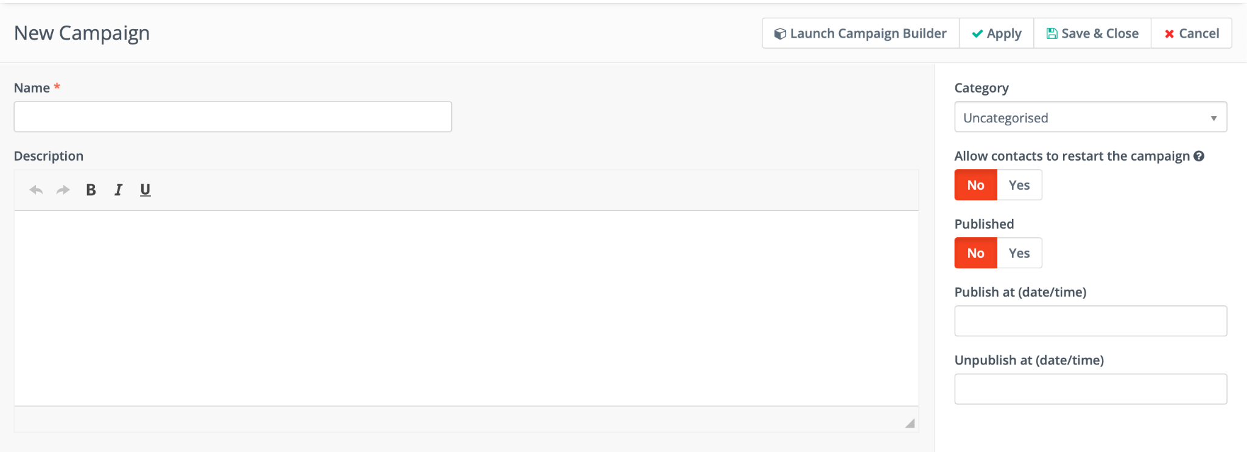

1. Give the Campaign a name (remember to use proper naming convention)
2. Click Launch Campaign Builder to start building the campaign.
3. Click add a contact source.

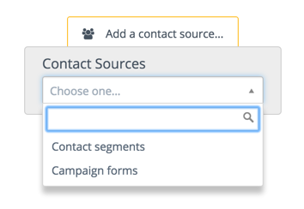

Contacts can be triggered from segments or forms. Choose contact segments if you want to target contacts that share a specific attribute such as “located in the UK”. Choose campaign forms if you want to start the campaign once the user completes a form such as a newsletter sign up form.

You can select a mix of both contact source types by clicking the gray selector once chosen.

1. After selecting a contact source you can then select the bottom gray selector to choose an event.

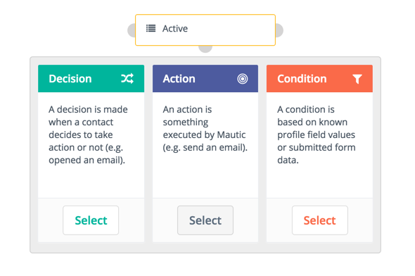

**Unsubscribe campaign logic**

We have created a personalized unsubscribe campaign, in order to correctly control the flow of contacts who want to be receive ESB emails and differentiate them from transactional emails since Mautic cannot do it on its own.

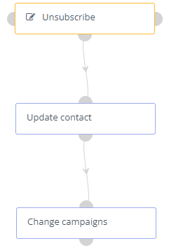

Our contact source will be a form created to control contact information and the reason why the contact want to unsubscribe.

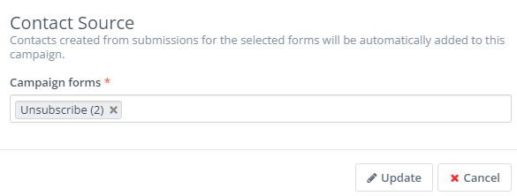

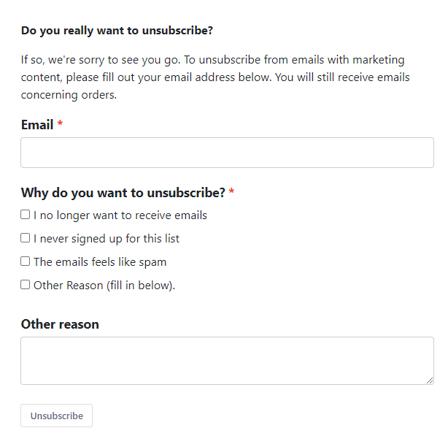

Then we update the contact based on the “Allow marketing emails” custom field.

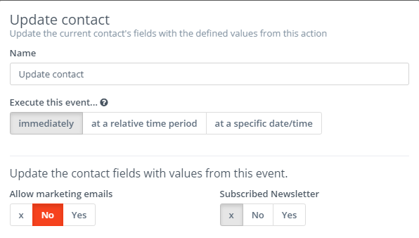

To finish the process, we remove the contact from the campaign, in this way we make sure that the contact can enter the campaign again, in case they have changed their mind.

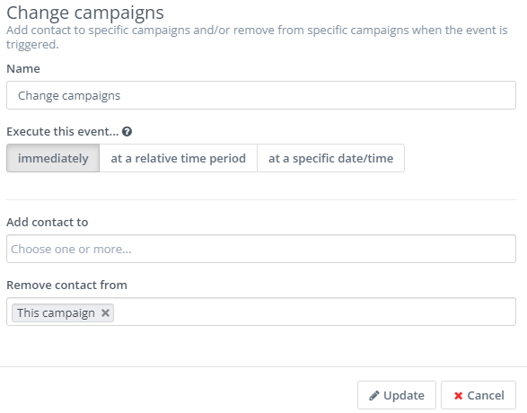

**NOTE:** Contacts are added to the correct segments based on their behaviour.

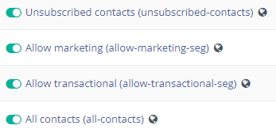

**Themes**

Installing a new theme:

* Navigate to the settings icon in the top right and then click themes.
* Click choose file and click your theme in .zip format and click upload.
* This theme will now be installed.

You can also download any of the pre-installed themes from this page. Themes can also be edited and re-uploaded however be aware that they will return to the default theme after new updates.

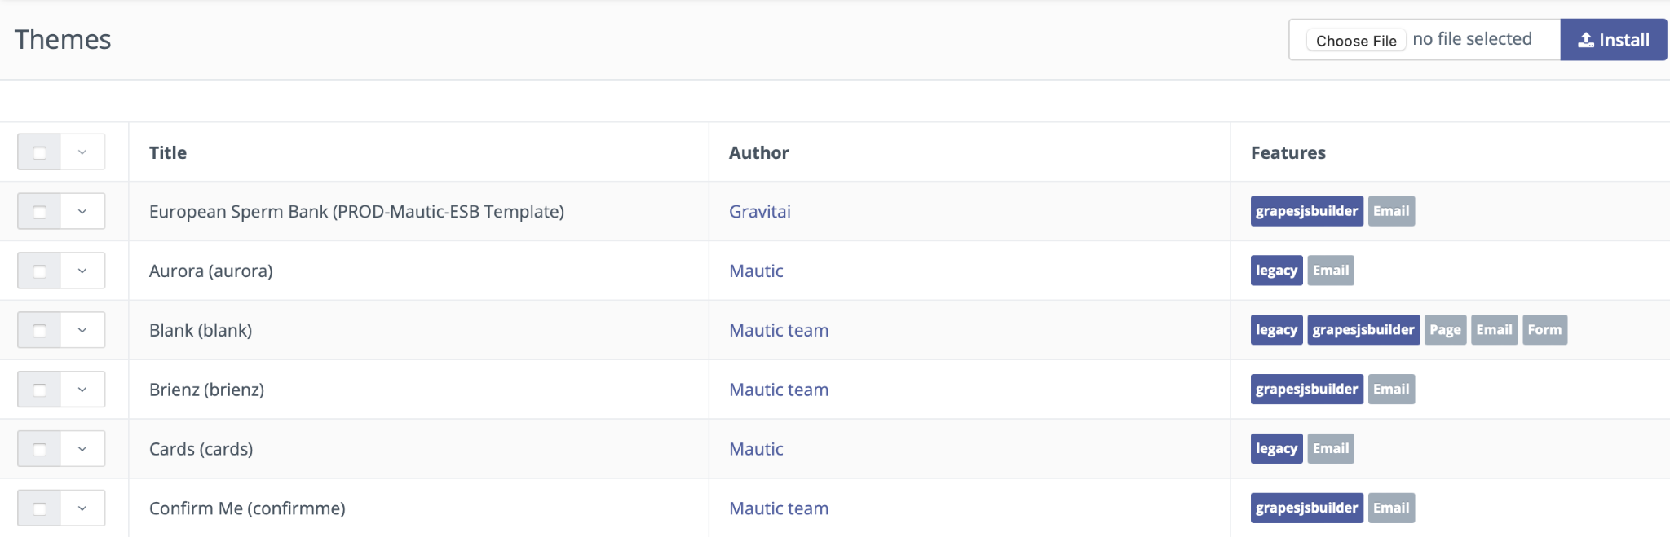

**Email Creation**

To create a template email, you’ll first need to go to the Email section of Mautic. First click ‘Channels’ on the left-hand sidebar, and then select ‘Emails’.

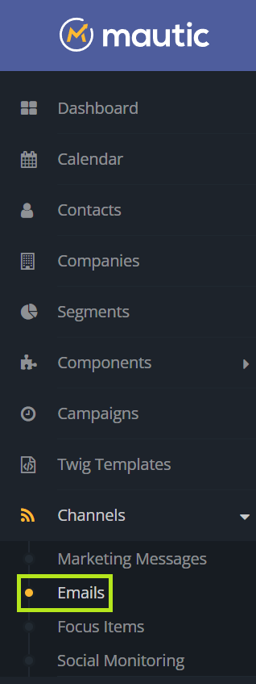

You’ll be brought to the central email screen where you can click ‘New’ to create a new email.

Emails can be created to be used within campaigns and other list activities. Emails provide a means for direct interaction with potential customers, clients, and contacts.

From there, you’ll be asked what type of email you want to create. In this case, select ‘New Template Email.’

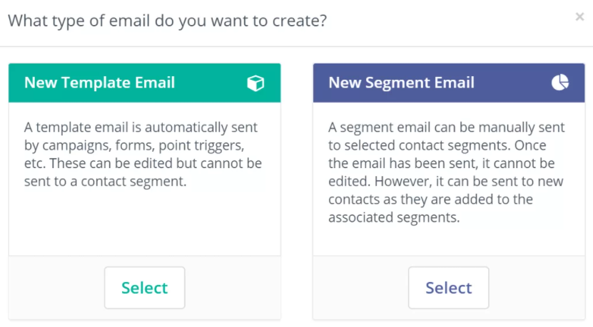

You’ll then be brought to an email builder which provides plenty of options for customizing the template.

**Select Your Template Theme**

First, you can select your template from the various themes available in Mautic. You could also code or import your own template if you so choose.

In this case, we have created a template for ESB emails.

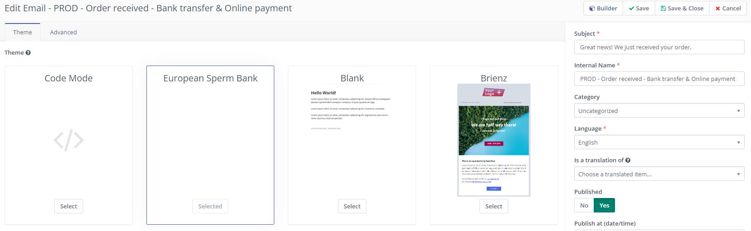

**Adding Email Details**

On the right-hand menu, you’ll find a number of different fields that allow you to schedule, track, and organize your email campaigns. There, you can select which segment your email will be sent to, and add details such as an internal name for your campaign and custom UTM tags.

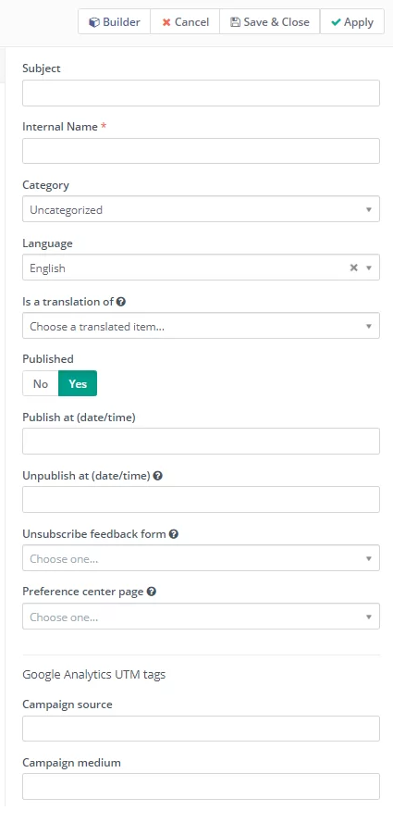

**Advanced Email Settings**

To further customize your email, click the ‘Advanced’ button in the top left-hand corner. There, you can select the ‘reply to address,’ add attachments, and create a plain text version of your email if you so choose.

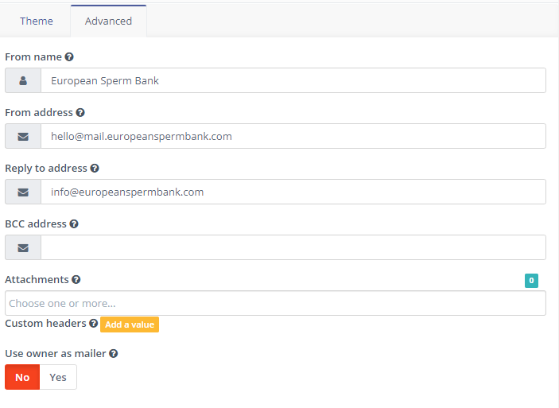

**Creating Email Content**

Once you’ve selected a template and added any necessary details, the next step in building an email in Mautic is to add the content itself. To do so, click ‘Builder’ in the top right-hand corner.

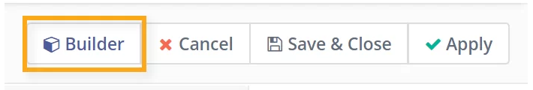

To edit a pre-existing element, simply click on it. You can then make any necessary changes in the “Blocks” section or in the “Style manager” section on the right-hand side. Your changes will automatically update in the preview version of your email.

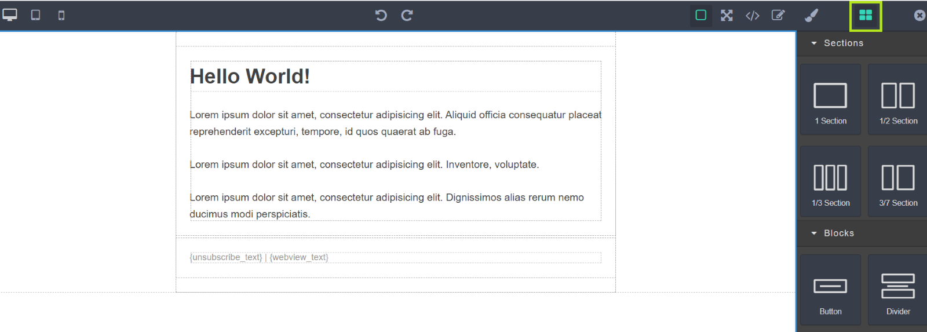

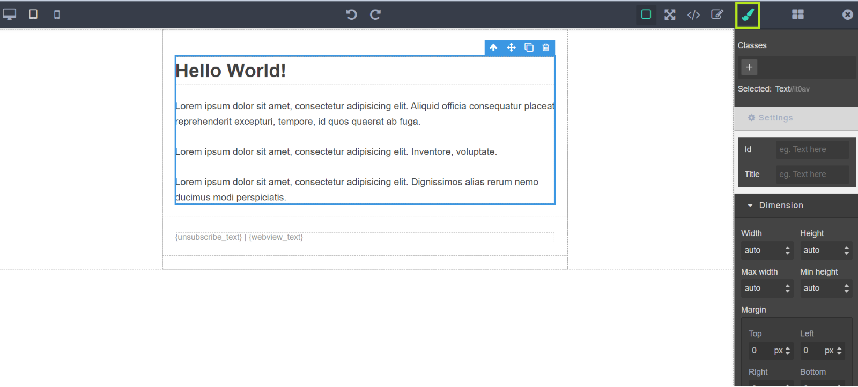

**Twig templates**

Twig is a modern template engine for PHP, is a library designed to combine templates with a data model to produce documents.

We are using the features provided by the twig templates within our emails, this way we can create reusable layouts/components.

To create a twig block, go to the menu tab named "Twig templates"

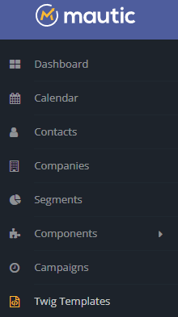

Go to the top right and click on "New"

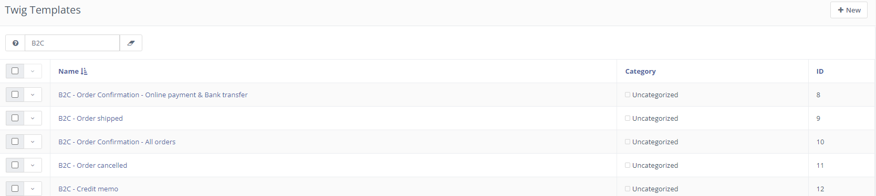

Add the twig block name and twig code, and click “Save & close”.

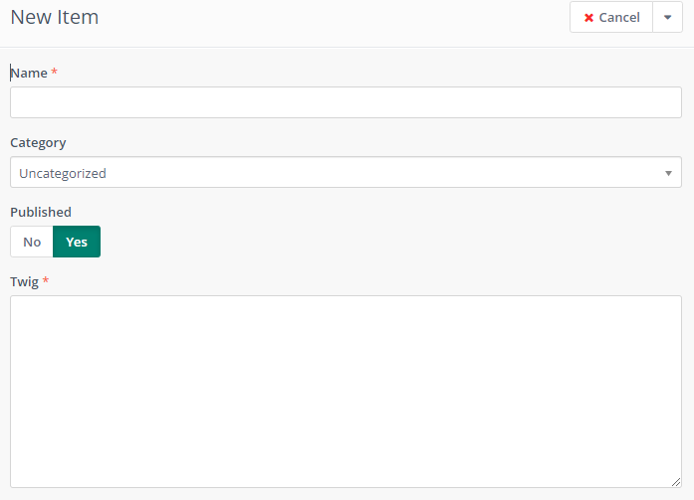

Example:

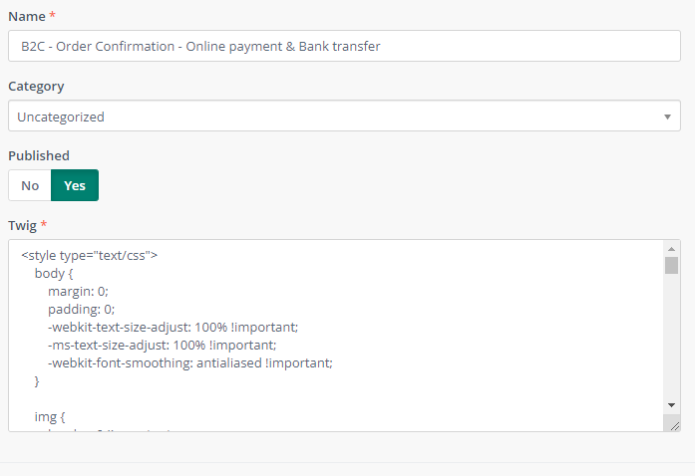

This will create the new Twig block and assign it an ID

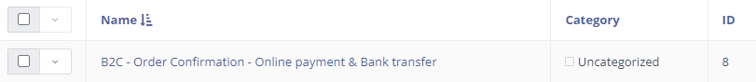

To call this twig block in our emails, the following structure must be followed “{twigtemplate=ID}”.

**Example**

